Wildern School

Skoolkit will be holding a 10% discount week in our Eastleigh Store from Saturday 15th – Friday 21st July, where all items listed below will be subject to a 10% discount for this time only. This is for new starters only.

2023 Price List Day Wear
Bottle/Red Striped Clip on Tie
£6.50
Bottle V-Neck Sweatshirt Embroidered with 2 logos 30" …… £15.50  32" & 34" …… £16.50  XS …… £17.50  S, M & L …… £18.50  XL …… £19.50 |  |  | Plain Short or Long Sleeve Unisex Eco Shirts Twin Pack  From £15.00
Boys Black Trousers  From £17.99 | Girls Black Trousers  From £22.99 |  |  |  | Girls SSK308  Must be  22-28"W 22"L  30-38"W 22"L | Davenport Skirt  Knee Length  …… £24.99  …… £29.99
x36 | …… | Iron on Name Tapes  £4.99 x72 |  | …… | £5.99

PE Wear
Bottle/Red/ ZR20 Polo Shirt Embroidered with Logo  26/28" - 34/36" …… £17.50  38/40" - 46/48" …… £20.75 |  | Bottle/Red/ ZR15 Long Sleeved Top  Embroidered with Logo  26/28" - 34/36" …… £18.65  38/40" - 44/46" …… £21.85 |  | Bottle/Red/ ZR46 Full Zip Top Embroidered with Logo  30/32" - 34/36" …… £25.99  38/40" - 46/48" …… £31.99
Bottle/Red/ | ZR50 Shorts |  | Red Football Socks
24/26" - 28/30" …… | £11.95 |  | Junior …… £4.99
32" - 40" …… | £13.95 |  | Senior …… £5.50
Prices are correct at the time of printing

Opening Hours

Mon – Fri 9:00 am – 5:30 pm
31 Leigh Road,
Eastleigh, SO50 9FF
Sat 9:00 am – 5:00 pm
eastleigh@skoolkit.co.uk

Dear Parent/Carer,
You can find your child’s full school uniform all year round in our Eastleigh store on Leigh Road. We advise you purchase early in the summer holidays as we get very busy. (Please refer to our website www.skoolkit.co.uk for store opening times.)

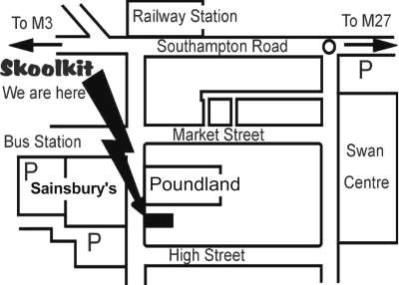

ONLINE ORDERS need to be placed by:

WEDNESDAY 9TH AUGUST
For delivery before the start of the 2023/24 school year

Please note that orders placed online throughout July, August & September can take up to 14 working days.

Postage charges apply, please refer to our website for costs.

Free delivery will be available with any size order placed online by using the following code when viewing your basket online.
Saturday 22nd July – Saturday 29th July
Code: SUMMER2023

PLEASE VISIT US AT:
WWW.SKOOLKIT.CO.UK

