The Learning Resource Centre (LRC)
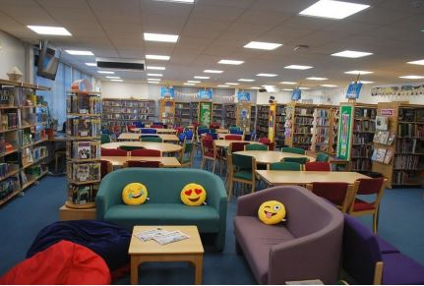
The LRC is open Monday to Friday from 8.00am to 5.00pm. You may borrow or return items during this time.
Students can borrow up to 4 items (books and DVD’s) at a time. Books can be reserved if they are out on loan.
The LRC as gone online. You can log in with your Wildern email address and date of birth – DDMMYYYY. Select your book and select reserve at school.
There are several computers in the LRC and everyone has access to them. However, these computers must be booked on the day you wish to use them and are to be used for self-study only.
The LRC staff and a team of student librarians can assist in finding information for projects and self-study. We can also help with book selection and what to read next.
The LRC also has a number of extra-curricular activities and a sample is below.
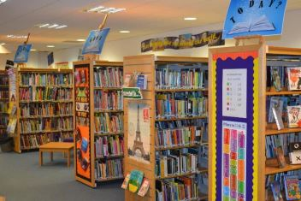
What else goes on in the LRC?
- LRC Reading Tournament: Earn positive refs along with certificates and prizes.
- LRC Loyalty Bookmark: (Years 8, 9, 10 and 11). These are stamped each time a student takes a book out. Collect 6 stamps and be awarded a gold e-ref.
- Children’s Book Award – Read and review proof copies of titles that we receive from publishers.
- Reading Buddies – (Years 7 & 10) Year 10 students sit with Year 7’s and listen/support with their reading.
- SIG Reading Group – Meet in the LRC throughout the year to read and discuss group sets of books.
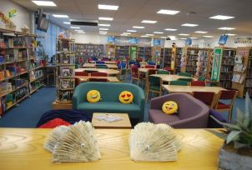
- Blind Date with a Book – is one example of many different activities held throughout the year.
- Schooltastic Book Club – Book club brochures are distributed to students throughout the year. Schooltastic publishers offer books at greatly reduced prices.
- Student Librarians – We have a team of dedicated student librarians who support the LRC at break and lunchtimes.

