SCHOOL UNIFORM

All students are expected to uphold the high standards of the school. This is especially applicable to uniform. It is our belief that if students are appropriately dressed for school, they are in the correct mind-set for learning and the expectations this brings.

If a student is wearing incorrect uniform they will be told to correct it for the next school day and a mark will be placed on their uniform tracker. Each time a row is completed on the tracker, a sanction is put in place. Should uniform breaches happen on a regular basis, parents will be asked to attend a meeting with the DOPA to discuss a way forward as this is seen as persistent defiance.

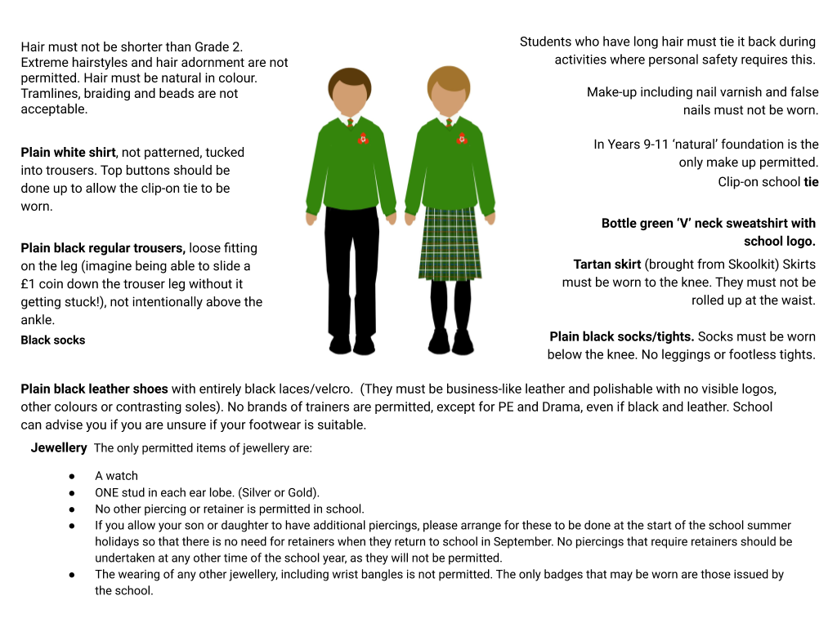
School uniform is available to purchase from Skoolkit at 31 Leigh Road, Eastleigh, SO50 9FF or online at www.skoolkit.co.uk.

Summer uniform: from May half term
There is an option to wear a summer short sleeved shirt with school logo that can be worn without a tie and sweatshirt
- If a short sleeved shirt without a logo is worn, the school tie needs to be worn
- If a sweatshirt is worn, a tie always needs to be worn

Coats
- Dark outdoor coat of plain, sober colour and unpatterned material is preferable. (Fluorescent strips advisable for added safety on dark evenings)
- Coats should be waterproof, hooded tops, tracksuit type jackets and other outdoor clothing of this type, particularly if emblazoned with logos/motifs or large lettering are not acceptable
- Any coats should always be worn over school jumpers, not as a replacement, and should be removed when indoors

PE Kit
- The PE Kit can be purchased from Skoolkit.
- White Wildern Polo shirt (purchased from Skoolkit)
- Green Shorts (purchased from Skoolkit)
- Red Football socks OR white sports/trainer socks
- Sports or astro trainers
- Swimming shorts (plain, preferably navy blue or black)
- Swimming costume (plain, preferably navy blue or black)

KS3 (Year 7 and 8) - Dance
- Boys and Girls - Green PE shorts (not leggings), White Wildern Polo shirts, bare feet

KS4 - GCSE Dance
- Boys - Tracksuit bottoms, black t shirt, bare feet - black Wildern Dance t shirts and hooded jackets are available to order direct from the dance department in June and September
- Girls - Black leggings, black t shirt or leotard or vest top, bare feet - black Wildern Dance t shirts, vest tops and hooded jackets are available to order direct from the dance department in June and September

Prohibited/Banned items
- Knives and other weapons
- Drugs (other than prescription medication that is kept with first aid by arrangement)
- Drug paraphernalia
- Aerosol sprays
- Tippex and solvents
- Chewing gum
- Energy Drinks, including Lucozade
- Cigarettes, tobacco and other smoking paraphernalia
- E Cigarettes and vaping equipment
- Students are also advised not to bring cash or valuable possessions into school, as we cannot accept responsibility for loss or damage.
- Mobile Phones, iPads, MP3 Player, headphones should not be visible. Such equipment, if brought into school, should be kept in the students' school bag. (If such equipment is used without permission or it is seen around the school site during break times and lunch times, it will be confiscated and if a repeat offence parents or carers will be required to collect the item from reception).

